

**Claremont High School Academy**

Key Stage 4

Curriculum Guide

2013

KS4 Curriculum Guide

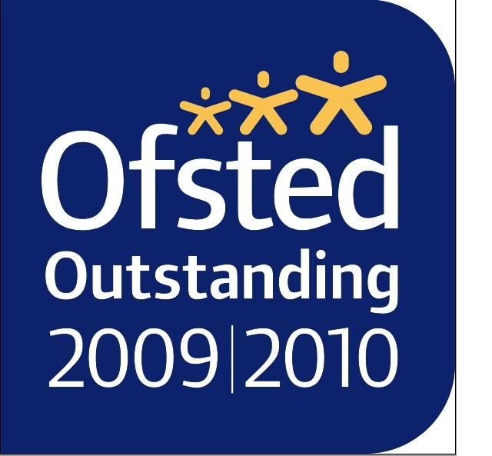

**CONTENTS**

|  |  |
| --- | --- |
| * **Introduction & Option Columns** | Page 3-5 |
| * **Art & Design** | Page 6 |
| * **Business Studies / Btec Business** | Page 7-8 |
| * **Drama** | Page 9 |
| * **Performing Arts** | Page 11 |
| * **English** | Page 13 |
| * **Fashion & Textiles** | Page 14 |
| * **French** | Page 15 |
| * **Geography** | Page 16-17 |
| * **German** | Page 18 |
| * **Graphic Products** | Page 19 |
| * **History** | Page 20 |
| * **Btec Hospitality** | Page 21 |
| * **ICT and Computing** | Page 22-23 |
| * **Mathematics** | Page 24 |
| * **Music** | Page 25 |
| * **Option Support** | Page 26 |
| * **Physical Education** | Page 27 |
| * **Product Design** | Page 28 |
| * **Religious Education** | Page 29 |
| * **Science and Triple Science** | Page 30-31 |
| * **Sociology** | Page 32 |

**Key Stage 4**

During the first three years at Claremont High School Academy all pupils study a broadly based Key Stage 3 curriculum which involves a wide range of subjects. In Years 10 and 11 this changes to a study in greater depth of fewer subjects with a view to taking and passing GCSE examinations at the end of Year 11.

Probably, for the first time in their lives, pupils will have a major ‘say’ in the choice of subjects they study. Their views are important as they are the people who will be doing the work, but they will need help and advice from their parents/carers and their teachers in making their choices. This is to ensure that they embark upon the course best suited to their aptitude and abilities. Although pupils are only making option choices for Years 10 and 11 their ideas about their long-term future can affect their decisions.

**The Core Curriculum**

At Key Stage 4 all pupils follow GCSE or equivalent courses in English, Mathematics and Science. For science most students study the separate sciences (Biology, Physics & Chemistry) or the Dual Science Award with a small number studying Btec Applied Science. All pupils take Physical Education, PSHE and Religious Education and, in the case of Religious Education, a significant proportion will be entered for the GCSE.

**EBacc**

There is now a strong emphasis on pupils studying a core range of English Baccalaureate, or EBacc, subjects of English, Maths, Science, Languages and History or Geography. This has in turn led to less genuine choice in the options. Many pupils will study 10 or more GCSE subjects but it is important to remember that it is the **quality** of the GCSE grades achieved that will keep the options open in later life for A/AS levels and University.

**The rationale behind the guided choices offered at Key Stage 4**

* To meet the requirements of the National Curriculum
* To engage and interest our students
* To provide courses that match students’ career aspirations
* To raise attainment and open up choices for post 16 education
* Our aim is to maximise the chances of all students of all abilities

**OPTIONS – a balancing act**

Whatever your ambitions you will probably end up changing your mind a number of times before you find the right career for you. That is why it is so important to study a broad range of examination subjects. Of course you will need to choose the subjects that suit you, but try to make sure you do not exclude any careers you might think of later.

**Option Columns for 2013**

* You are asked to choose **one subject from each column**. In the Languages column, all pupils **must** choose the language they currently study ++*unless they have been given the option of the additional Btec subject.*
* In the Humanities column, all pupils **must** choose either History or Geography ++*unless they have been given the option of the additional Btec subject.*
* Pupils are strongly advised to speak to their form tutor / current subject teachers if they are unsure about their choices.
* More able pupils will already be able to achieve an extra GCSE in Further Maths. This is a **directed** choice and the school will make the final choice of subjects allocated. We will try to meet all choices so far as is possible, but please note, that some classes may be oversubscribed and the school will necessarily select pupils. We have included a wide range of subjects in columns A and B but please note, not all classes will run if insufficient numbers opt for the subject.

|  |  |  |  |
| --- | --- | --- | --- |
| **LANGUAGES** | **HUMANITIES** | **OPTION A** | **OPTION B** |
| GCSE  German | GCSE  History | GCSE  Art | GCSE  Business |
| GCSE  French | GCSE  Geography | GCSE  Textiles | Btec  Business |
| Sociology  Art | Btec Business  ICT | Btec  Hospitality | ICT |
|  |  | GCSE  Graphics | GCSE  PE |
|  | | GCSE  Performing Arts | Btec  Sport |
| GCSE  Music | GCSE  Computing |
| Triple  Science | GCSE  Drama |
| GCSE  History | Triple  Science |
| GCSE  Geography |  |
| GCSE  Product Design |  |

*1*

**Which subjects can you take at Key Stage 4?**

|  |  |
| --- | --- |
| **Subject** | **Is this the subject for me? Do I meet these requirements?** |
| **Triple Science** | Currently working on target to achieve a level 6 and teacher recommendation based on practical skills and progress. |
| **Dual Science** | Currently working on target to achieve a level 5 and teacher recommendation based on practical skills and progress. |
| **BTEC Applied Science** | Pupils who have an ability to organise work and meet deadlines. |
| **History** | Teacher recommendation based on progress to date. |
| **Geography** | Teacher recommendation based on progress to date. |
| **French** | Keen, hard working students who have a good enough ability to progress at GCSE.  Teacher recommendation based on progress. |
| **German** | Keen, hard working students who have a good enough ability to progress at GCSE.  Teacher recommendation based on progress. |
| **Double Language**  **French / German** | Currently taking the double language in Year 9. Teacher recommendation based on progress to date. |
| **Option Support** | Teacher recommendation from the Learning Support Department. |
| **Music** | Pupils must demonstrate via pre-existing instrumental grades or an aptitude for a musical instrument or singing. |
| **Performing Arts** | Keen, hard working students who have shown an interest in Performing Arts in early options. |
| **PE (GCSE)** | PE Teacher recommendation to take GCSE or BTEC, based on Year 9 progress. |
| **ICT / Computing** | Teacher recommendation based on your Year 9 progress and grades. |
| **GCSE Business** | Must have a genuine interest in the subject and have good written communication skills. |
| **BTEC Business** | Ability to meet deadlines and determination to succeed. |
| **Art** | Keen, hard working students who have shown an interest in Art & Design and have an interest in all forms of Art work. |
| **Textiles** | Keen, hard working students who have shown an interest in Textiles. |
| **Product Design** | Teacher recommendation based on your Year 9 progress and grades. |  |
| **Graphics** | Teacher recommendation based on your Year 9 progress and grades. |
| **BTEC Hospitality** | Organised students who have shown an interest in the subject and are willing to work hard. |
| **Sociology** | Added to the options for students not taking a language |

**ART AND DESIGN**

**Exam Board: AQA**

GCSE Art and Design consists of two units;

1. **A portfolio of coursework;** made up of projects set by your Art and Design teacher to suit your progress and needs, it will give you the opportunity to develop skills and techniques in a variety of art disciplines. The coursework unit is taught throughout year 10 and the first term of year 11, it is **worth 60% of the final mark**
2. **A 10 hour practical exam.** The exam questions are given out early in January and you have all of the spring term to undertake research, experiment and develop ideas to prepare for the two day exam. For the exam you have 10 hours of dedicated time to produce your final piece of work. The exam unit is **worth 40% of the total mark**.

There is no written element although you will be expected to be able to discuss your artwork and the work of Artists and Designers in context.

You do not need to be outstanding at drawing to do well at Art and Design but you must be keen to think creatively. You will be encouraged to develop interests and strengths as the course proceeds through research and experimentation. You will be expected to work hard in class and independently between lessons. There will be opportunities to work in a wide variety of disciplines including; Drawing, painting, graphic design, ceramics, printmaking, textiles, collage, mixed media, sculpture, digital arts, animation and photography.

All students will get an introduction to the vocational potential of Art and design. You will get an overview of possibilities of careers through work related learning as well as gaining the technical knowledge and skills associated with art and design that are used in the workplace or further education. At Claremont there is an emphasis on connections with practicing artists, designers and makers to develop awareness of historical and contemporary practice through practical experiences. This will include working to live art and design briefs and with visiting professional artists, designers and craft workers.

**C:\Users\kate.guy\AppData\Local\Microsoft\Windows\Temporary Internet Files\Content.IE5\YZRNUOIQ\MC900036377[1].wmfWhy study Art and Design?**

An Art and Design education develops your creativity and communication skills and it encourages independent thought and risk taking. With a creative outlook you will have a huge range of employment opportunities. A creative education can lead to careers in many areas of the creative sector, including [advertising](http://en.wikipedia.org/wiki/Advertising) and marketing, architecture, [broadcasting](http://en.wikipedia.org/wiki/Broadcasting), craft, fashion, [film](http://en.wikipedia.org/wiki/Film_industry), video and photography, internet and [music](http://en.wikipedia.org/wiki/Music_industry) industries, 2D design, [print](http://en.wikipedia.org/wiki/Publishing) and [electronic publishing](http://en.wikipedia.org/wiki/Electronic_publishing), and [video and computer games](http://en.wikipedia.org/wiki/Computer_games).

For further information talk to the teachers in the Visual Arts department. **BUSINESS STUDIES**

**Exam Board: Edexcel**

By the end of the GCSE Business course learners will be required to demonstrate knowledge and understanding of:

* The dynamic nature of business, including motivations for social enterprise
* Local, national and international contexts
* The integrated nature of business problems and solutions
* Apply a critical perspective to the theory and current practice of business
* Evaluate quantitative and qualitative evidence to make reasoned judgements
* Develop a conceptual framework of business within society

**Examination:**

Compulsory Unit; Externally Assessed:

**Key Topics:**

* Showing enterprise
* Spotting a business opportunity
* Putting a business idea into practice
* Making the start-up effective
* Understanding the economic context
* Marketing
* Meeting customer needs
* Effective financial management
* Effective people management
* The wider world affecting business

**Controlled Assessment:**

Compulsory Unit: Internally Assessed Under Controlled Conditions

**Key Points:**

* Research/investigation – approximately two curriculum weeks of time.
* Analysis/evaluation of task (final write-up) – approximately one curriculum week of time.
* Same content as above.

**BTEC BUSINESS**

**Exam Board: Edexcel**

The Business Studies Department at Claremont High School Academy has an excellent track record in our delivery of BTEC Programmes resulting in 100% Pass rate each year. In September 2012 all BTEC courses are changing with the introduction of a compulsory external assessed examination, prior to this all recent BTEC programmes have been assessed solely by internal assessment (coursework). Students should seek advice from a member of the business studies department before choosing the course.

**Core Units (mandatory)\***

* Enterprise in the Business World
* C:\Program Files\Office\MEDIA\CAGCAT10\j0222017.wmfFinance for Business

**Unit Optional specialist (4 from below)\***

* Promoting a Brand
* Principles of Customer Service
* Sales and Personal Selling
* Introducing Retail Business
* Providing Business Support
* Recruitment, Selection and Employment

Learners must complete both core units, plus a further 4 units which will be chosen by the school. Unit 2 will be externally assessed; all other units will be internally assessed and moderated by the exam board.

**Accreditation and Progression**

Pupils who successfully complete the course will received a pass, merit or distinction. The course is equivalent to one GCSE Qualification. The Level 3 BTEC National Diploma in Business is a natural progression for pupils who have followed the level 2 programme. This course is offered here at Claremont and is the equivalent to 2 A Levels.

**Further information**

If you require further information regarding BTEC Business, please contact Mr. Wall (brian.wall@claremont-high.org.uk)

**DRAMA**

**Exam Board: AQA**

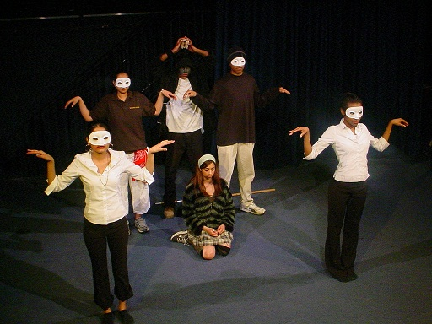

**What is GCSE Drama all about?**

GCSE Drama encourages you to explore and actively engage in a wide range of creative and stimulating activities, to develop as effective and independent learners and as critical and reflective thinkers with enquiring minds.

It helps you to develop and demonstrate competence in a range of practical, creative and performance skills. The subject also encourages you to work imaginatively and creatively in collaborative contexts, generating, developing and communicating ideas.

**The GCSE Drama course is in two parts:**

**Controlled Assessment**

60% of the total marks (marked out of 120)

Over the duration of the GCSE course, you will study five controlled assessments:

* Devised thematic work
* Acting
* Improvisation
* Theatre in Education
* Physical Theatre

Your two highest controlled assessment marks are submitted towards your final GCSE grade, each with a weighting of 30% (60 marks each).

**Internally assessed and externally moderated.**

**Written Paper**

1 hour 30 min  
40% of the total marks (marked out of 80)

The written paper comprises three sections:   
A – Practical work completed during the course  
B – Study and performance of a scripted play  
C – Study of a live theatre production seen.

You must answer Question 1 from Section A and then choose one further question from either Section B or Section C.

**Externally set and marked.**

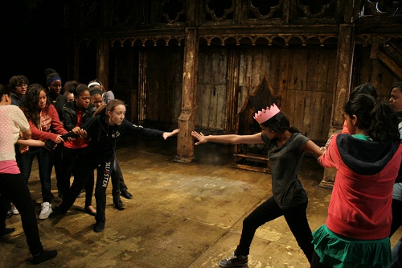

**What could I do next with GCSE Drama?**

There are many things you can go on to do with a GCSE in Drama. You could go on to take an AS or Advanced GCE in Drama and Theatre Studies, or a BTEC Level 3 qualification in Performing Arts. You may wish to take a GCSE in Drama for its own sake, perhaps to form the basis of a future interest or as part of a range of other subjects. Or you might wish to go into a job where it is useful to have had experience of drama, or where you will need to use some of the skills developed during this course. These might include careers in such fields as retail, travel and tourism, sales and marketing or any career that involves meeting people face to face. The study of drama can help you develop transferable skills that you can take into any career or job.

**GCSE PERFORMING ARTS**

**Exam Board: Edexcel**

The Performing Arts course is designed for enthusiastic and motivated students who are interested in gaining a greater understanding of the performing arts through practical and theoretical assignments, and who enjoy taking part in acting, singing and dancing. The course is based upon a series of practical and vocational assignments which are designed to develop skills whilst at the same time giving students opportunity to gain great personal enjoyment from the art of performance



* Individual Showcase
* Preparation, Performance and Production
* The Performing Arts Industry

**Optional Units are chosen based on the skill set of the learners. These include:**

* Acting Skills
* Dance Skills
* Musical Theatre Skills
* Music Performance Skills
* Production Skills for Performance
* Plus other units which focus around aspects of Music, Drama, Dance, or Technical Production

**Key Skills**

* Take part in many performances and presentations of work
* Learn the skills needed to provide technical support for performances
* Develop and extend personal learning styles and group work
* Develop skills in all aspects of performance including acting, singing and dance.
* Work with a range of specialist teachers
* Develop an understanding of production values
* Have the opportunity to audition for, and participate in at least one large scale production.
* Gain knowledge and understanding of the business side of the Performing Arts
* Take part in a mini-musical and support and participate in activities taking place during lunchtime and after school.

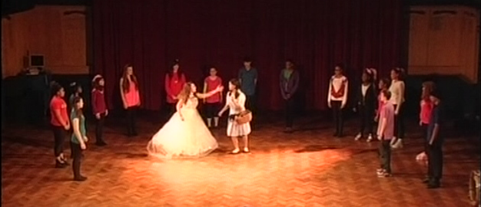

***Highlights from ‘The Wizard of Oz’ (February 2012).***

*Students in Year 10 study a Musical Theatre Unit which allows them to work on an abridged version of a popular and famous production during lesson time. The project is run on a vocational and professional model, including auditions rehearsals, dress and technical rehearsals, and with stage lighting, band and costume.*

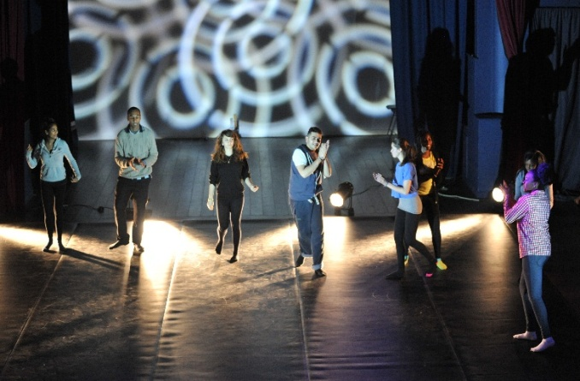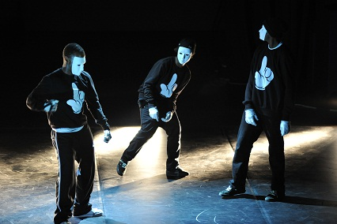

***‘Rush’ 2012***

*“Rush” is our Dance Showcase which demonstrates the crossover between curriculum and the extracurricular life of the school. Performing Arts students receive training in dance within BTEC units, and have the opportunity to celebrate these skills, together with their own choreography, at the annual Dance Spectacular.*

**ENGLISH LANGUAGE & LITERATURE**

**Exam Board: AQA**

This specification allows candidates to demonstrate their ability in functional English; to investigate and analyse language and, to experiment and use language creatively. The specification offers a skills-based approach to the study of English. This enables candidates to make ‘fresh’ and individual responses to each element of assessment.

The scheme of assessment is unitised, offering flexibility. Students sit their English Language examination in June of year 10 and then sit the English Literature examination in June of year 11.

This is a two-year course offering students the opportunity to study a range of published work, as well as improving their own abilities to communicate effectively both verbally and in the written form.



The syllabus is offered at Foundation and Higher levels.

**Specification at a Glance**

**Unit 1: Understanding and producing non-fiction texts**

External examination

40% of the total GCSE marks Time: 2 hours Marks: 80

Section A: Reading

20% of the total GCSE marks Time: 1 hour Marks: 40

Section B: Writing

20% of the total GCSE marks Time: 1 hour Marks: 40

**Unit 2: Speaking and Listening**

Controlled Assessment

20% of the total GCSE marks Marks: 45

**Unit 3: Understanding and producing Creative Texts**

Controlled Assessment

40% of the total GCSE marks. Marks: 80

**FASHION & TEXTILE DESIGN**

**Exam Board: AQA**

**What is involved in the GCSE Fashion & Textiles course?**

In Year 10 you will complete two foundation projects learning new key skills in designing & making colourful and exciting textiles and fashion products (such as dresses, skirts, tops, bags, hats, cushions & interior furnishing products). You will show evidence of drawing and making skills and the use of formal elements, materials and techniques used in fashion & textile designing in the form of an A3 portfolio; you will develop ideas and final outcomes to meet given design briefs by selecting suitable materials and techniques; you will show skills in construction techniques and processes and carry out a variety of research & product analysis to communicate your ideas. In Year 11 you will complete the final major GCSE project, in the form of a controlled assessment. You will be assessed accordingly in-line with the GCSE criteria as shown.

**Key skills you will learn**

In this final major project you will explore the specialist materials and manufacturing techniques used in the fashion & textile industries. You will also further develop key skills in fashion illustration, block pattern cutting, garment construction, using decorative seams, putting in button-holes & zips, adding features such a pockets, pleats and decorative necklines to help you make your final fashion garment or accessory. You will experiment with stencil, block & heat transfer printing, appliqué, quilting, hand and machine embroidery, fabric manipulation and surface embellishments using a variety of sewing machines.

**What resources are available?**

A fully equipped textiles studio consisting of sewing machines, an embellisher, an over-locker, a heat printing press for sublimation printing, together with the use of the new digital laser cutter for fabric stencilling and engraving, to help you learn how CADCAM (computer-aided design & manufacture) is used in the fashion industry.

**Opportunities**

* You will have the opportunity to visit leading museums and galleries to support your studies.
* You will have the opportunity to work directly with real fashion & textile designers during workshops in school and with local educational programmes.
* You will also have the chance to visit the London College of Fashion and work with their out-reach designers and attend work-related talks.

Pupils who study GCSE Fashion & Textile Design will have the opportunity to work in areas such as fashion illustration, pattern cutting, fashion designing and manufacturing; printed & constructed textiles, fashion retail & buying to mention a few.

**FRENCH**

**Exam Board: AQA**

**Subject Requirements:**

For those who study French we offer a two-year course to GCSE. The option to study German to GCSE as well as French is open to those who are in the Double Language group in Year 9.

**Subject Information:**

French is a major European language spoken in France, Belgium, Switzerland, many countries in Africa as well as parts of Canada and other islands around the world. A GCSE certificate in French is a useful additional qualification to have for the future, especially when combined with Business, Maths or Science, because it widens employment prospects and is a vital part of a balanced education. It is also highly regarded by universities.

Topics covered at GCSE build on and enhance knowledge of those taught at KS3. Themes dealt with include Media, the Environment, Holidays, Health etc. Pupils develop skills in listening, reading, writing and speaking enabling them to understand and discuss a range of themes.

**Assessment:**

All 4 skills are assessed. (Listening, Reading, Speaking and Writing)

C:\Users\alison.green\AppData\Local\Microsoft\Windows\Temporary Internet Files\Content.IE5\3RVQYA6U\MC900188457[1].wmfPupils are entered for either Higher or Foundation level at GCSE for Reading and Listening. Speaking and Writing are un-tiered.

**Unit 1: Listening (20%)**

Exam- Foundation 35mins –Higher 45mins

**Unit 2: Reading (20%)**

Exam- Foundation 30mins –Higher 50mins

**Unit 3: Speaking (30%)**

Students will complete a number of speaking controlled assessments. The French teachers conduct and assess all Speaking assessments. The best 2 controlled assessments will be submitted for moderation by AQA and will count towards the final GCSE grade. Pupils are required to speak for 4-6 minutes for grades A*-C.

**Unit 4: Writing (30%)**

Students will also complete written controlled assessments. The best 2 controlled assessments count towards the final GCSE grade and will be externally assessed by AQA. The requirement for the written assessment is 400 to 600 words across the two tasks for grades A*-C.

**Extra Curricular:**

As we approach GCSE we offer revision sessions focussed on the 4 skills with the French subject teachers.

**GEOGRAPHY**

**Exam Board: AQA A**

**Is this the right subject for me? Ask yourself ... do I want to:**

* Learn about and understand the world I live in – how it has been previously, and how it will change in the future?
* Develop skills that will help me in other subjects and in employment, such as ICT, analysis, problem solving and research?
* Complete practical work away from the classroom – based around a residential fieldtrip?
* Learn how to work in a team with other students?
* Learn through investigating, not simply listening and reading?

**Subject Information**

The AQA A syllabus has been chosen to help our students explore people and their environment as well as contemporary events and issues which are relevant locally, nationally and globally. It will help students to understand their environment and community. It creates an opportunity to explore the humanitarian and scientific challenges and opportunities facing society today.

A student particularly well suited to this subject will be one who has a genuine interest in current affairs, problem-solving, handling and interpreting data, and who enjoys challenging themselves to think beyond the obvious; being open to learn new skills which Universities and employers value highly in prospective candidates is also helpful. Students who are interested in decision-making and empathy work will enjoy exploring and solving complex social and environmental issues as well as gaining an understanding of how they shape the world along with natural processes.

**In 2012 89% of students achieved A* - C in their Geography GCSE at Claremont.**

**Assessment**

**There are three units for the course that students will complete over 2 years:**

**Unit 3**

**Controlled Assessment (25%)**

A Fieldwork Investigation based upon data collected on a residential fieldtrip.

**Unit 2**

**Human Geography (37.5%)**

Topics include:

‘Population Change’, ‘Globalisation’ and ‘Changing Urban Environments’

**Unit 1**

**Physical Geography (37.5%)**

Topics include:

‘The Restless Earth’, ‘The Challenge of Weather and Climate’ and ‘The Coastal Zone’

Units 1 and 2 are assessed by written examinations that will take place at the end of Year 11. Unit 3 is the Controlled Assessment and will take place during Year 10. Higher and Foundation tiers are available so the course will be tailored to students’ requirements.

**Residential Fieldwork**

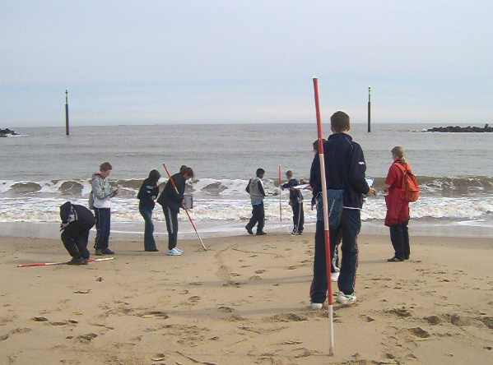As well as being an unforgettable experience for the students, the residential fieldtrip is a significant part of the course that helps prepare students for their Unit 3 Controlled Assessment, whilst also giving them a better understanding of the theory and knowledge required for Units 1 and 2.

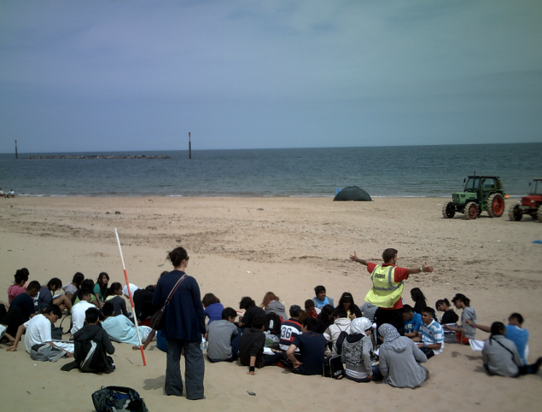

**What can I do after I have completed the course?**

Geography really is an education for life. Employers and universities value the broad range of transferable skills that geography delivers. Geography fits neatly with science, arts and humanities. A GCSE in Geography is excellent preparation for a career in sciences, planning, resource and countryside management, tourism and recreation and environmental management and development.

**GERMAN**

**Exam Board: AQA**

**Subject Requirements:**

For those who study German we offer a two-year course to GCSE. The option to study French to GCSE as well as German is open to those who are in the Double Language group in Year 9.

**Subject Information:**

German is a major European language spoken in Germany, Austria and Switzerland. A GCSE certificate in German is a useful additional qualification to have for the future, especially when combined with Business, Maths or Science, because it widens employment prospects and is a vital part of a balanced education. It is also highly regarded by universities.

Topics covered at GCSE build on and enhance knowledge of those taught at KS3. Themes dealt with include Media, the Environment, Holidays, Health etc. Pupils develop their skills in listening, reading, writing and speaking enabling them to understand and discuss a range of themes.

**Assessment:**

All 4 skills are assessed. (Listening, Reading, Speaking and Writing)

C:\Users\alison.green\AppData\Local\Microsoft\Windows\Temporary Internet Files\Content.IE5\KK4UQWGA\MC900200325[1].wmfPupils are entered for either Higher or Foundation level at GCSE for Reading and Listening. Speaking and Writing are un-tiered.

**Unit 1: Listening (20%)**

Exam- Foundation 35mins –Higher 45mins

**Unit 2: Reading (20%)**

Exam- Foundation 30mins –Higher 50mins

**Unit 3: Speaking (30%)**

Students will complete a number of speaking controlled assessments. The German teachers conduct and assess all Speaking assessments. The best 2 controlled assessments will be submitted for moderation by AQA and will count towards the final GCSE grade. Pupils are required to speak for 4-6 minutes for grades A*-C.

**Unit 4: Writing (30%)**

Students will also complete written controlled assessments. The best 2 controlled assessments will count towards the final GCSE grade and will be externally assessed by AQA. The requirement for the written assessment is 400 to 600 words across the two tasks for grades A*-C.

**Extra Curricular:** As we approach GCSE we offer revision sessions focussed on the 4 skills with the German subject teachers.

**C:\Documents and Settings\kelly.martinez.CHS\Local Settings\Temporary Internet Files\Content.IE5\KKRWR7LL\MCj01558250000[1].wmfGRAPHIC PRODUCTS**

**Exam Board: AQA**

**What is involved in the GCSE Graphic Products course?**

The course runs over two years and sees students undertake a range of different projects which are designed to allow you to explore your creative talents and practical making abilities. In Year 10 you will undertake a range of smaller graphics projects which build key skills and experience in designing and making which you will need in Year 11 when you begin on your Major project.

The Graphic Products course gives you the chance to work with compliant materials, such as card, paper and board, and Computer Aided Design packages (CAD), such as Photoshop & Illustrator, in order to produce high quality, professional looking 2D graphics, virtual 3D images and 3D graphical products.

**How will I be assessed?**

In Year 10 your projects will be formally marked by your teacher against the marking criteria set by the exam board (AQA). Throughout the Graphics course you will complete your Design portfolios online and submit them for making using the MLE. In Year 11 you will begin on your final, major project which is worth 60% of your overall grade. The written exam makes up the remaining 40% of your grade. The exam comprises of questions relating to your knowledge of materials and processes as well as your ability to design products.

**What resources are available?**

Whilst studying on this course you will have access to some of the latest cutting edge technology that the Design & Technology department has to offer such as the Laser cutter & computer controlled vinyl /card cutter. You will also have access to the Technology department’s new Computer Aided design suite which is equipped with a suite of new computers fully equipped with the latest computer aided design software such as Adobe Photoshop & illustrator, Pro engineer, 2D Design V2 & Sketch- up. This software will be used to help aid the design & manufacture of the final product. You will also have access to a graphics studio, equipped with computers, scanners, printers & graphic tablets.

**What will I do with a GCSE in Graphic Products?**

The skills that you will gain from this course will allow you to go on and study a design course at college. If you were to decide to pursue a career in design you will have been taught a vast range of different fundamental skills that colleges, universities and employers will require.

Pupils who study GCSE Graphic products often go on to careers in: Graphic Design, Product Design, Automotive Design, and Animation & Architecture.**HISTORY**

**Exam Board: AQA**

**Subject Information:**

History enables pupils to acquire the abilities to research effectively, think logically, and evaluate and interpret evidence. Pupils also learn to develop a structured argument, and communicate persuasively in both verbal and written form.

**In 2012, 79% of pupils achieved an A*-C grade**

Pupils are now taught in sets, according to their ability level.

**Subject Requirements:**

The subject is ideally suited to someone who has a genuine interest in History, who is curious about the world around them and who enjoys the process of analysis and evaluation. Pupils must also be prepared to read widely, contribute to discussion and meet essay deadlines.

**Department Information:**

We are a strong department, with teachers having studied History at some of the UK’s top Universities (UCL, LSE, Oxford).

**Further Studies & Employment:**

Many of our high-calibre GCSE pupils study History at A-Level and read History at some of the top universities in the UK. It is a subject highly regarded by these universities.

History is a subject favoured by many employers. Indeed, it is particularly useful if you are thinking about a career in Law, Journalism, Civil Service (including the Foreign Office), Accountancy, Politics, Banking & Finance, Academia, Business, Management or Teaching.

**Assessment**

There are three units that pupils will take over two years:

**Unit 3**

**Controlled Assessment (25%)**

**Topics include:**

**the Home Front and Women’s role in both wars**

**Unit 2**

**Twentieth Century Depth Studies (37.5%)**

**Topics include:**

**Nazi Germany and the**

**Vietnam War**

**Unit 1**

**International Relations 1945-1991 (37.5%)**

**Topics include:**

**the Cold War & the collapse of Communism**

Units 1 & 2 are assessed in a written exam at the end of Year 11. Unit 3 is the Controlled Assessment and will take place during the Spring Term of Year 11. There is no Higher or Foundation paper. All pupils will take the same exam, regardless of ability.

**Extra-Curricular:**

Each year we organise an overseas trip to look at the First World War battlefields and trenches in Belgium. This is an extremely popular and long-standing trip, with many pupils citing it as one of their most memorable experiences at Claremont.

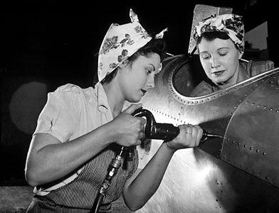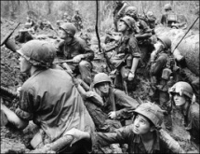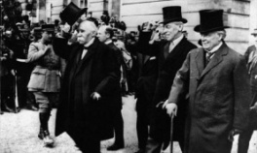

**BTEC First Extended Certificate in HOSPITALITY**

This is a practical, hands-on course and is an excellent choice if you have a genuine love of food and cooking. While cooking you will be expected to wear Chef Whites. Parent support is important as ingredients will be needed each week.

BTEC First Certificates are part of a suite of vocationally focused qualifications offered at Claremont High School Academy. They are flexibly structured to give candidates the opportunity to form qualification, which can be highly individual to their personal aptitudes, interests and ambitions where appropriate. Units undertaken will provide a basic introduction to the world of Hospitality and will allow students to gain a broad understanding of the subject area.

This is a practical, work-related course that is equivalent to 1 GCSE Grades A*-C. You will study units that are based upon realistic workplace situations, activities and demands. You will complete 5 units of work over the 2 years – these are assessed by 5 individual assignments. Each unit is assessed through small, manageable tasks. There are no exams and your final grades are based purely on assignments. You have the opportunity to achieve a Distinction, Merit or Pass grade.

**The units you will complete your assignments on are :**

The Hospitality Business; Basic Culinary Skills; Planning and Running a Hospitality Event.

**Career Opportunities:**

The BTEC First Extended Certificate in Hospitality is designed to equip students with the knowledge, understanding and skills required for success in current and future employment or for progression to courses such as BTEC Nationals in Hospitality supervision. The qualification has been developed to meet the needs of the Hospitality industry by offering a nationally recognised qualification. Careers include Chef, Hotel Management, Product Development, Environmental Health Officers, Nutritionists, Dieticians, Event Organisers or Catering.



**INFORMATION AND COMMUNICATION TECHNOLOGY**

The increasing use of technology in all aspects of society makes confident, creative and productive use of ICT an essential skill for life. ICT capability encompasses not only the mastery of technical skills and techniques, but also the understanding to apply these skills purposefully, safely and responsibly in learning, everyday life and employment. ICT capability is fundamental to participation and engagement in modern society.



This course will be useful if you’re looking to study Information Technology and obtain the skills, knowledge and qualifications to improve your prospects for either employment or further study.

Claremont High School Academy offers a choice between GSCE ICT and GCSE Computer Science.

**Exam Board: AQA**

The GCSE qualification focuses on the practical application of ICT within a business and social context.

Students complete two units in a controlled assessment environment as well as an exam.

**How will you be assessed?**

Unit 1: Systems and Applications in ICT

External examination 40% of the total GCSE marks 2: The Assignment: Applying ICT

Controlled Assessment 60% of the total GCSE marks

For all units you will learn lots of different skills and techniques such as spreadsheets, databases, desk top publishing, web site creation, creating graphics, multimedia presentations etc. The course will be built on the skills you have learnt in KS3.

**An example of the topics covered:**

* Systems life cycle
* Working with information to solve problems
* Operating systems and user interfaces
* Applications software
* Word processing, DTP, web design and other presentation software
* Graphics production and image manipulation
* Spreadsheets and modelling software
* Databases
* Web browsing and e-mail

**COMPUTER SCIENCE GCSE**

Computing is of enormous importance to the economy, and the role of Computer Science as a

discipline itself and as an ‘underpinning’ subject across science and engineering is growing rapidly. Computer technology continues to advance rapidly and the way that technology is consumed has also been changing at a fast pace over recent years.

The growth in the use of mobile devices and web-related technologies has exploded, resulting in new challenges for employers and employees. For example, businesses today require an ever-increasing number of technologically-aware individuals.

This is even more so in the gaming, mobile and web related industries and this specification has been designed with this in mind. Students studying this specification will learn how to create applications that:

* run on mobile devices
* operate in a web enabled environment.

In addition they will:

* learn how to create simple computer games
* gain an understanding of the fundamental
* concepts around creating software applications
* have opportunities to work collaboratively.

**Exam Board: AQA**

The course is split between controlled assessments and an exam.

The controlled assessment is the practical part, and uses computer programming skills. The idea is to program a solution to a given problem. The exam will be based around the fundamentals of computing, which will include hardware and software as well as the understanding of computer systems.

C:\Program Files\Office\MEDIA\CAGCAT10\j0199805.wmf

**How will you be assessed?**

60% of the marks will be of practical controlled assessments.

40% of the marks will be of the exam paper.

The practical will be internally assessed and externally moderated.

**Course content**

You will learn lots of different skills such as programming, logic, error handling, algorithms, software development, application testing, networking, database concepts and computer structure including systems, hardware, CPU and storage. 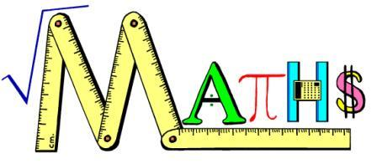**MATHEMATICS**

**Exam Board: Edexcel - GCSE in Mathematics Linear A [1MA0]**

Students continue to study Mathematics at Key Stage 4, normally working towards a GCSE examination at a level appropriate to their ability and the progress they have made in recent years. In common with all GCSE Mathematics syllabuses this involves tiered levels of entry that limit the possible grades that can be achieved in the final examination. Final decisions on levels of entry are not made until later in the course. However, students continue to work in ability groups that determine their likely entry level.

For all GCSE Mathematics syllabuses the National curriculum programmes of study and associated statements form the subject content. In practice, this involves the study of Mathematics under the headings of Statistics and Probability, Number and Algebra, Geometry and Measure. Elements of Functional mathematics have been embedded into the new specifications and assessments. This introduction ensures that students have the skills they need to use Mathematics in real life contexts.

The non-calculator paper emphasises the need for pupils to be numerate and to have a good grasp of basic number work if they are to succeed at GCSE. Calculators also have to be used efficiently where appropriate. Pupils will require a scientific calculator at GCSE.

**Assessment:**

Two written papers: each contributes 50% of the final grade

Tiered papers - This is a 2-Tier GCSE Course and can be taken at both Foundation and Higher level. This ensures every pupil has a chance of achieving a Grade C.

|  |  |
| --- | --- |
| **Exam entry level** | **GCSE grades available** |
| Foundation tier | C, D, E, F, G |
| Higher tier | A*, A, B, C, D(E allowed) |

**The Functional Elements of Mathematics are assessed on each paper**

• 30-40% of the Foundation Tier papers

• 20-30% of the Higher Tier papers.

**Overview of content**

• Number

• Algebra

• Geometry

• Measures

• Statistics

• Probability

**MUSIC**

**Exam Board: Edexcel**

**Subject Specific Entry Requirements**

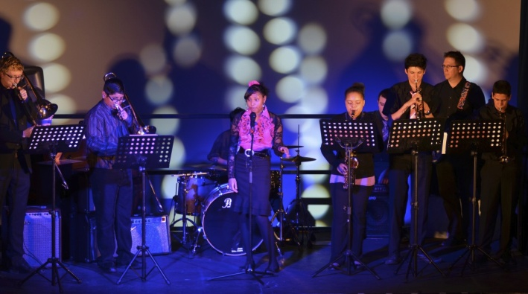Students must be able to play an instrument or sing to an elementary standard. The ability to read music would be an asset but this is not essential.

Students will explore four different areas of study:

* Western Classical Music
* Music in the 20th Century
* Popular Music in Context
* World Music

**Listening and Appraising (40%)**

You will study the history and theory of music and develop your listening skills through the study of music across a variety of styles and genres. This part of the course involves responding to questions on recorded extracts of music based on the 12 set works which you will study. The written paper lasts 1 hour 30 minutes and it is marked externally.

**Composition (coursework/controlled conditions - 30%)**

You will compose two pieces of music in different styles using Music technology software including Sibelius and/or Cubase. This coursework is externally moderated.

**Performance (coursework/controlled conditions - 30%)**

All GCSE Music students are entitled to subsidised instrumental lessons at the school. You will perform as a both a soloist (15%) and as part of an ensemble (15%). This coursework is externally moderated.

**The benefits of studying GCSE Music:**

GCSE Music will prepare you to study both Music and Music Technology AS Levels. There are many opportunities in higher education and many career possibilities for those proficient in handling music and music technology. Music and Music Technology careers include working as a composer, performer, music therapist, teacher, broadcaster, publisher, sound engineer, record producer, as well as other technologically based media industries including film and television.

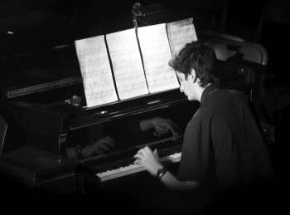GCSE Music students are expected to willingly participate in at least one extra-curricular activity whilst they are on the course.

**OPTION SUPPORT**

Each year a number of selected pupils are given the opportunity to take one less option at GCSE so that they can concentrate on raising their achievement in their remaining subjects.

Pupils are encouraged to bring class work and homework from any subject for assistance, so this is an ideal opportunity to improve overall grades by receiving additional help with their work. They can also receive help with coursework and examination technique at this time and there are opportunities to improve basic skills.

Apart from teachers with specific subject expertise in English, Economics, Languages and R.E. there is also a well-stocked resource centre and ICT equipment, including the Internet, available to assist pupils with their studies.

Some students have Option Support who also attend college courses. This allows those students to catch up on work that may have been missed.

Option Support will be offered to selected pupils only and does not appear in the Options Columns.

**PHYSICAL EDUCATION - GCSE**

**Exam Board: Edexcel**

**Subject specific entry requirements:**

Pupils choosing this course must have an interest in anatomy, physiology, health and fitness training. Pupils should have a good level of practical ability and ideally should have represented the school in at least one sport.

**60% of the course is practical** – students select 4 activities and are assessed on:

• Physical performance, coaching or officiating, worth 48%

• Analysis and improvement of performance, worth 12%

**40% of the course is theory** – students will cover

• Exercise and Training

• Safety aspects and risk assessment in physical activity and sport

• Applied anatomy and physiology

There is a 1¾ hours written exam consisting of multiple-choice questions, short answer questions and longer style scenario questions.



**BTEC First Extended Certificate in SPORT**

**Exam Board: Edexcel**

BTEC First Extended Certificate in Sport is a nationally recognised qualification. It is 25% external examination and 75% coursework based, some of which is practically based. The course is designed to give learners a wider understanding and appreciation of health-related fitness, sports and exercise through a selection of optional specialist units.

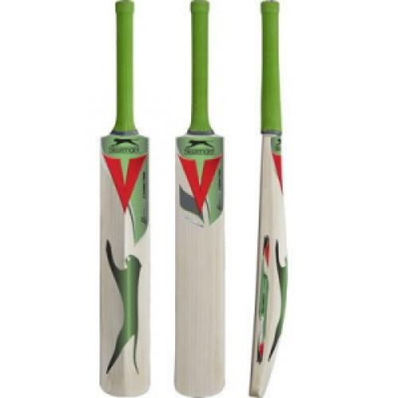

**PHYSICAL EDUCATION - CORE**

All students will continue to take part in P.E. for one hour a week. A variety of activities such as football, badminton, netball and basketball will be taught with the emphasis on fitness, team work and participation rather than an end of year examination. PE will remain compulsory for all students.

**PRODUCT DESIGN**

**Exam Board: AQA**

**What is involved in the GCSE Product Design course?**

The GCSE Product design course builds upon & develops the skills pupils were taught in year 9. Pupils will continue to undertake a range of different practical designing & making activities where they will be continually challenged to learn & use wide range of tools, equipment & manufacture processes. The projects undertaken teach pupils the necessary skills which they will need to enable them to create products with commercial viability.

Students will also learn about the work of past & present designers, different design movements & how these have influenced the world of design. Pupils will be taught traditional drawing and manufacture techniques alongside the latest in computer aided design & manufacture software.

**How will I be assessed?**

In year 10 students will undertake two designing & making assignments. Each design & make assignment is designed to test each pupils ability to undertake different aspects of the designs process including research, design & developing coherent design ideas, manufacturing the final product and evaluating the success of the product.

In year 11 they will undertake a final major project. This project will account for 60% of your overall grade. A written exam will make up the remanding 40% of your overall grade which will take place at the end of year 11. The exam will further test student’s knowledge of materials, manufacturing processes & designing skills.

**What resources are available?**

Whilst studying on this course you will have access to some of the latest cutting edge technology that the Design & Technology department has to offer such as the Laser cutter & computer controlled vinyl /card cutter. You will also have access to the Technology department’s new Computer Aided design suite which is equipped with a suite of new computers fully equipped with the latest computer aided design software. This software will be used to help aid the design & manufacture of the final product. You will also have access to two workshops and a graphics studio which are all fully equipped with all of the necessary tools & equipment you will need in order to produce your final design.

**What will I do with a GCSE in Product Design?**

There are a vast range of different college courses, jobs & careers available to students who have gained a GCSE in Product design. Many students will move on to a future career as a product designer, however the skills that you will gain from studying Product design will be transferable between many different disciplines such as architecture, engineering, industrial design, graphics design, game design, animation & fashion.

**RELIGIOUS EDUCATION**

**Exam Board: OCR**

R.E. is compulsory in Years 10 and 11 where all students follow a GCSE course.

It is aimed at giving the students a greater understanding of the various faiths and cultures on offer in our multi-faith society and an appreciation of the contribution of this diversity of faith and culture in our society.

Students will look at Christian Philosophical and Ethical debates such as Life after death, Good and Evil, Medical Ethics and War and Peace.

**Assessment**

There is no coursework, just four modular exams, two on Philosophy of Religion and two on Religious Ethics.

R.E. at GCSE is an interesting subject to take and is accepted by all universities as an academic subject. Many students go on to study R.E. as an A’ Level and find the philosophy element both challenging and interesting.

**What can I do with RE?**

It is useful for a whole range of occupations, e.g. Lawyer, Journalist, Architect, Accountant, Historian, and Teacher. The nature of the subject is such that it makes you question and think about a whole range of subjects. If you are thinking of going on to study science-based subjects then it is a good extra subject, interesting and thought-provoking as a contrast to Science or Technology.

**C:\Documents and Settings\chris.digby\Local Settings\Temporary Internet Files\Content.IE5\EOSIMNEU\MC900237945[1].wmfSCIENCE - DUAL AWARD**

**Exam Board: EDEXCEL**

Dual Award Science comprises of GCSE Science and GCSE Additional Science. The content in GCSE Science covers topics which are relevant to everyday life. Additional science builds on the work covered in the first GSCE and covers topics which are essential for post 16 science qualifications. Students will receive a separate grade for each course.

**The scheme of assessment**

|  |  |  |  |
| --- | --- | --- | --- |
| **GCSE Science** | **B1** | • Classification, variation and inheritance  • Responses to a changing environment  • Problems of, and solutions to a changing environment  • The Earth’s sea and atmosphere  • Materials from the Earth  • Acids  • Obtaining and using metals  • Fuels  • Visible light and the Solar System  • The electromagnetic spectrum  • Waves and the Universe  • Waves and the Earth  • Generation and transmission of electricity  • Energy and the future | **External assessment (75%)**  • Based on 3 structures 1 hour exams worth 25% each  **Internal assessment (25%)**  • Practical Assessment activities , provided by Edexcel, marked by the teacher and externally moderated  **This is completed in Year10** |
| **C1** |
| **P1** |
| **GCSE Additional Science** | **B2** | • The building blocks of cells  • Organisms and energy  • Common systems | **External assessment (75%)**  • Based on 3 structures 1hour exams worth 25% each  **Internal assessment (25%)**  • Practical Assessment activities , provided by Edexcel, marked by the teacher and externally moderated  **This is completed in Year11** |
| **C2** | • Atomic structure and the periodic table  • Ionic compounds and analysis  • Covalent compounds and separation techniques  • Groups in the periodic table  • Chemical reactions  • Quantitative chemistry |
| **P2** | • Static and current electricity  • Controlling and using electric current  • Motion and forces  • Momentum, energy, work and power  • Nuclear fission and nuclear fusion  • Advantages and disadvantages of using radioactive materials |

This is a popular choice for those students who might go on to study a Science at AS or A2 level. Students will be continuously assessed throughout the course with regular feedback.

Students who study Dual Award Science will, if they obtain a B grade or above in both courses and meet the Mathematics and English requirements, be allowed to study any A level science course. **Btec Applied Science will be offered to pupils who would not benefit from taking the Dual Science course.**

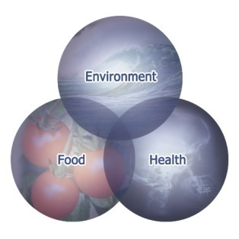**TRIPLE SCIENCE**

**Exam Board: Edexcel**

**Who can study Triple Science at GCSE**

Those students who obtain level 6 or above in their end of KS3 Science tests are allowed the option of studying GCSE exams in each of the three sciences: Biology, Chemistry and Physics. If students opt for this they must study all three subjects.

The structure of each subject course is identical and outlined below. You will notice that each student will study 6 core modules identical to those for the dual award. Therefore if a student is found not to be performing for any reason there is the option to transfer to the dual award. (Please note this done in discussion with parent, student and teacher as it will result in one less GCSE.).

**Why should I consider Triple Science?**

Students wishing to study ‘A’-level Sciences should strongly consider studying the separate sciences. They will be given this opportunity if they obtain at least a grade B in their desired science and meet the Mathematics and English requirements.

**Units & Assessment**

|  |  |  |
| --- | --- | --- |
| **Core + Additional (See Dual Award)** | **Extension Topics (In Year 11)** | **Assessment Model** |
| **B1+B2** | • Control systems  • Behaviour  • Biotechnology | **External assessment (75%)**  • Based on 3 structures exams worth 25% each  **Internal assessment (25%)**  • Practical Assessment activities , provided by Edexcel, marked by the teacher and externally moderated |
| **C1+C2** | • Qualitative analysis  • Quantitative analysis  • Electrolytic processes  • Gases, equilibria and ammonia  • Organic chemistry |
| **P1+P2** | • Radiation in treatment and medicine  • X-rays and ECGs  • Production, uses and risks of missing radiation from radioactive sources  • Motion of particles  • Kinetic theory and gases |

**Sociology**

**Exam Board: AQA**

*Sociology is only available for students not continuing with French or German*

**Subject Requirements:**

The subject is ideally suited to someone who has a genuine interest in understanding the relationship between individuals, groups, institutions and societies, who is curious about the world around them and who enjoys the process of analysis and evaluation. Pupils must also be prepared to read widely, contribute to discussion and meet essay deadlines.

**Subject Information:**

Sociology is a very interesting subject that looks at wide range of issues and topics about the world we are living in.

Students who choose to study sociology will develop a wide range of knowledge and understanding about society, and how sociologists study and understand its structures, processes and issues. Sociology is exciting, interesting and relevant to students’ lives and this specification encourages students to take a questioning approach to evidence and issues, thus developing their critical, evaluation skills, essential for A level study.

**Sociology will**: encourages an understanding of the individual and social differences in the students' own and other societies

* encourages students to analyse critically the nature and source of information and to form arguments based on evidence
* encourages students to reflect their own experience of the social world in which they live.
* It will also provide a strong basis for progression to further studies, including [A-level, English and Sociology](http://web.aqa.org.uk/qual/gce/humanities/sociology_noticeboard.php).

**Assessment**

|  |  |
| --- | --- |
| **Unit 1** three compulsory topics | **Unit 2** three topic areas from four options |
| * Studying Society; * Education; * Families - Three Compulsory topic areas   Written Paper – 1 hour 30 mins | * Crime and Deviance; * Mass Media; * Power; * Social Inequality - Candidates choose three topic areas from four options   Written Paper – 1 hour 30 mins |